SERVIDOR CORREO
root@server:~# apt-get install postfix postfix-mysql dovecot-core dovecot-imapd dovecot-pop3d dovecot-lmtpd dovecot-mysql mysql-server
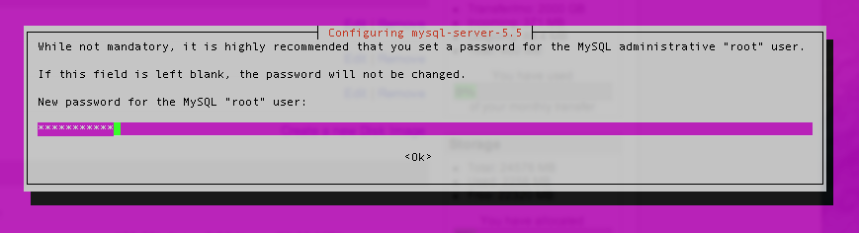
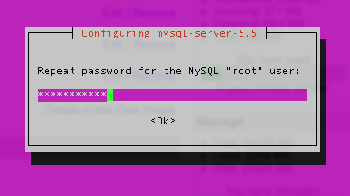

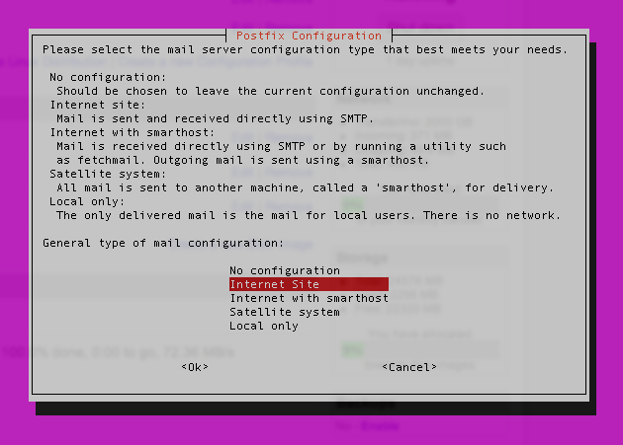
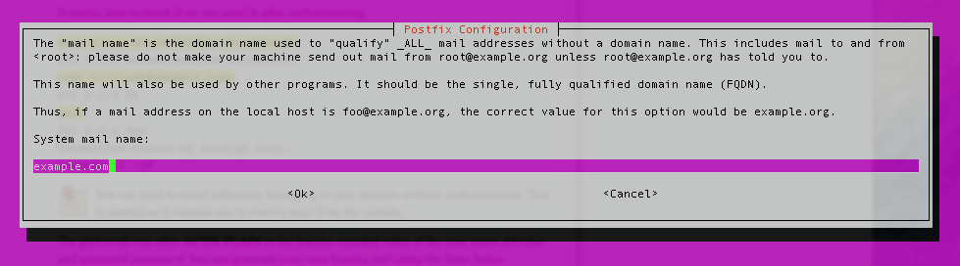

MySQL
Crea base datos
root@server:~# mysqladmin -p create mailserver
root@server:~# mysql -p mailserver
mysql> GRANT SELECT ON mailserver.* TO 'mailuser'@'127.0.0.1' IDENTIFIED BY 'mailuserpass';
mysql>FLUSH PRIVILEGES;
CREA EN DICHA BASE DE DATOS LAS SIGUIENTES TABLAS

CREATE TABLE `virtual_domains` (
`id` int(11) NOT NULL auto_increment,
`name` varchar(50) NOT NULL,
PRIMARY KEY (`id`)
) ENGINE=InnoDB DEFAULT CHARSET=utf8;
CREATE TABLE `virtual_users` (
`id` int(11) NOT NULL auto_increment,
`domain_id` int(11) NOT NULL,
`password` varchar(106) NOT NULL,
`email` varchar(100) NOT NULL,
PRIMARY KEY (`id`),
UNIQUE KEY `email` (`email`),
FOREIGN KEY (domain_id) REFERENCES virtual_domains(id) ON DELETE CASCADE
) ENGINE=InnoDB DEFAULT CHARSET=utf8;
CREATE TABLE `virtual_aliases` (
`id` int(11) NOT NULL auto_increment,
`domain_id` int(11) NOT NULL,
`source` varchar(100) NOT NULL,
`destination` varchar(100) NOT NULL,
PRIMARY KEY (`id`),
FOREIGN KEY (domain_id) REFERENCES virtual_domains(id) ON DELETE CASCADE
) ENGINE=InnoDB DEFAULT CHARSET=utf8;

AÑADIR DATOS A DICHAS TABLAS
INSERT INTO `mailserver`.`virtual_domains` (`id` ,`name`) VALUES
('1', 'geman.org'),
('2', 'hostname.geman.org'),
('3', 'hostname'),
('4', 'localhost.geman.org');

INSERT INTO `mailserver`.`virtual_users` (`id`,`domain_id`, `password` , `email`)
VALUES
('1', '1', ENCRYPT('administradorgemanorg', CONCAT('$6$', SUBSTRING(SHA(RAND()), -16))), 'administrador@geman.org'),
('2', '1', ENCRYPT('secondpassword', CONCAT('$6$', SUBSTRING(SHA(RAND()), -16))), 'email2@example.com');

INSERT INTO `mailserver`.`virtual_aliases` (`id`, `domain_id`,`source`, `destination`)
VALUES
('1', '1', 'support@geman.org', 'administrador@geman.org');

Postfix
root@server:~# cp /etc/postfix/main.cf /etc/postfix/main.cf.orig
root@server:~# nano /etc/postfix/main.cf
#mydestination = example.com,hostname. example.com, localhost.example.com, localhost
mydestination = localhost
myhostaname = ns1.geman.org
Crear archivos:
root@server:~# nano /etc/postfix/mysql-virtual-mailbox-domains.cf
user = mailuser
password = mailuserpass
hosts = 127.0.0.1
dbname = mailserver
query = SELECT 1 FROM virtual_domains WHERE name='%s'
root@server:~# service postfix restart
root@server:~#postmap -q example.com mysql:/etc/postfix/mysql-virtual-mailbox-domains.cf (devolverá 1)
root@server:~# nano /etc/postfix/mysql-virtual-mailbox-maps.cf
user = mailuser
password = mailuserpass
hosts = 127.0.0.1
dbname = mailserver
query = SELECT 1 FROM virtual_users WHERE email='%s'
root@server:~# service postfix restart
root@server:~# postmap -q email1@example.com mysql:/etc/postfix/mysql-virtual-mailbox-maps.cf (devolverá 1)
root@server:~# nano /etc/postfix/mysql-virtual-alias-maps.cf
user = mailuser
password = mailuserpass
hosts = 127.0.0.1
dbname = mailserver
query = SELECT destination FROM virtual_aliases WHERE source='%s'
root@server:~# service postfix restart
root@server:~# postmap -q alias@example.com mysql:/etc/postfix/mysql-virtual-alias-maps.cf
root@server:~# cp /etc/postfix/master.cf /etc/postfix/master.cf.orig
copia /correo/postfix/master.cf /etc/postfix
root@server:~#service postfix restart

Dovecot
root@server:~#cp /etc/dovecot/dovecot.conf /etc/dovecot/dovecot.conf.orig
root@server:~#cp /etc/dovecot/conf.d/10-mail.conf /etc/dovecot/conf.d/10-mail.conf.orig
root@server:~#cp /etc/dovecot/conf.d/10-auth.conf /etc/dovecot/conf.d/10-auth.conf.orig
root@server:~#cp /etc/dovecot/dovecot-sql.conf.ext /etc/dovecot/dovecot-sql.conf.ext.orig
root@server:~#cp /etc/dovecot/conf.d/10-master.conf /etc/dovecot/conf.d/10-master.conf.orig
root@server:~#cp /etc/dovecot/conf.d/10-ssl.conf /etc/dovecot/conf.d/10-ssl.conf.orig

root@server:~#cp /correo/dovecot/dovecot.conf /etc/dovecot/dovecot.conf.orig
root@server:~#cp /correo/dovecot/conf.d/10-mail.conf /etc/dovecot/conf.d/10-mail.conf
root@server:~#cp /correo/dovecot/conf.d/10-auth.conf /etc/dovecot/conf.d/10-auth.conf
root@server:~#cp /correo/dovecot/dovecot-sql.conf.ext /etc/dovecot/dovecot-sql.conf.ext
root@server:~#cp /correo/dovecot/conf.d/10-master.conf /etc/dovecot/conf.d/10-master.conf
root@server:~#cp /correo/dovecot/conf.d/10-ssl.conf /etc/dovecot/conf.d/10-ssl.conf
root@server:~#ls -ld /var/mail
drwxrwsr-x 2 root mail 4096 Mar 6 15:08 /var/mail
root@server:~#mkdir -p /var/mail/vhosts/example.com
root@server:~#groupadd -g 5000 vmail
root@server:~#useradd -g vmail -u 5000 vmail -d /var/mail
root@server:~#chown -R vmail:vmail /var/mail
root@server:~#chown -R vmail:dovecot /etc/dovecot
root@server:~#chmod -R o -rwx /etc/dovecot
Verificar que existen:
root@server:~#ls /etc/dovecot/dovecot.pem
root@server:~#ls /etc/dovecot/private/dovecot.pem
root@server:~#service dovecot restart

Abrir /etc/bind/db.geman.org
y añadir abajo del todo debajo de www
mail IN A 88.12.3.172
geman.org IN MX 1 mail1.geman.org

comprobar en var/log/mail.log
reiniciar:
root@server:~#/etc/init.d/bind9 restart

